|  |
| --- |
| **4COSC006C: Software Development I – TEST PLAN for Part 1** Student Name/ID: Gayathmi Mehansa Mohottige – w2053486  IIT Student Number: 20232182  Seminar Day/Time: Module Tutor Mr.Torin Wirasingha |

|  |  |  |  |  |  |
| --- | --- | --- | --- | --- | --- |
|  | Student Name: Gayathmi Mehansa Mohottige Student ID: w2053486 | | | | |
|  | TEST PLAN for Part 1 : Submit completed test plan with your code solution | | | | |
| Test Component | Test No. | Test Input | A - Expected Result | B - Actual Result  (or state ‘not attempted’) | Pass/Fail  (‘A’ matches ‘B’ == Pass) |
| Progress | 1 | Pass = 120  Defer = 0  Fail = 0 | ‘Progress’ displayed | ‘Progress’ displayed | pass |
| Progress (module trailer) | 2.1 | Pass = 100  Defer = 20  Fail = 0 | ‘Progress (module trailer)’ displayed | ‘Progress (module trailer)’ displayed | pass |
| 2.2 | Pass = 100  Defer = 0  Fail = 20 | ‘Progress (module trailer)’ displayed | ‘Progress (module trailer)’ displayed | pass |
| Module retriever | 3.1 | Pass = 80  Defer = 20  Fail = 20 | ‘Module retriever’ is displayed | ‘Module retriever’ is displayed | pass |
| 3.2 | Pass = 60  Defer = 0  Fail = 60 | ‘Module retriever’ is displayed | ‘Module retriever’ is displayed | pass |
| 3.3 | Pass = 40  Defer = 80  Fail = 0 | ‘Module retriever’ is displayed | ‘Module retriever’ is displayed | pass |
| 3.4 | Pass = 20  Defer = 40  Fail = 60 | ‘Module retriever’ is displayed | ‘Module retriever’ is displayed | pass |
| 3.5 | Pass = 0  Defer = 60  Fail = 60 | ‘Module retriever’ is displayed | ‘Module retriever’ is displayed | pass |
| Exclude | 4.1 | Pass = 40  Defer = 0  Fail = 80 | ‘Exclude’ displayed | ‘Exclude’ displayed | pass |
| 4.2 | Pass = 20  Defer = 0  Fail = 100 | ‘Exclude’ displayed | ‘Exclude’ displayed | pass |
| Validation | 5.1 | Pass = a | ‘Integer required’ | ‘Integer required’ | pass |
| 5.2 | Pass = 5 | ‘Out of range’ | ‘Out of range’ | pass |
| 5.3 | Pass = 100  Defer = 40  Fail = 0 | ‘Total incorrect’ displayed | ‘Total incorrect’ displayed | pass |
| Loops for multiple inputs | 6.1 | Program loops | Predicts multiple progression outcomes | Predicts multiple progression outcomes | pass |
| 6.2 | Enter ‘q’ | Exits loop | Exits loop | pass |
| Histogram | 7.1 |  | Window pops up and renders graph. Includes values for Progress, Trailer, Retriever and Excluded | Window pops up and renders graph. Includes values for Progress, Trailer, Retriever and Excluded | pass |
| 7.2 |  | Shows outcomes in total. | Shows outcomes in total. | pass |

**Test cases screenshots.**

**1)**

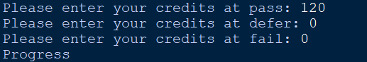

**2.1)**



**2.2)**

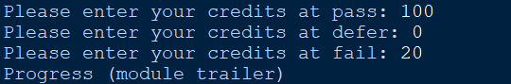

**3.1)**

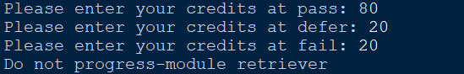

**3.2)**



**3.3)**

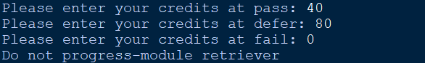

**3.4)**

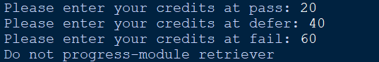

**3.5)**

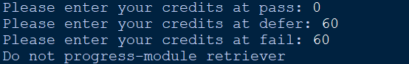

**4.1)**

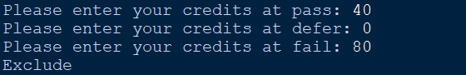

**4.2)**

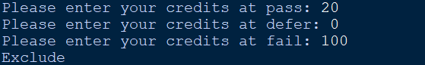

**5.1)**



**5.2)**



**5.3)**

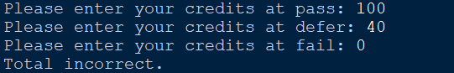

**6.1)**



**6.2)**

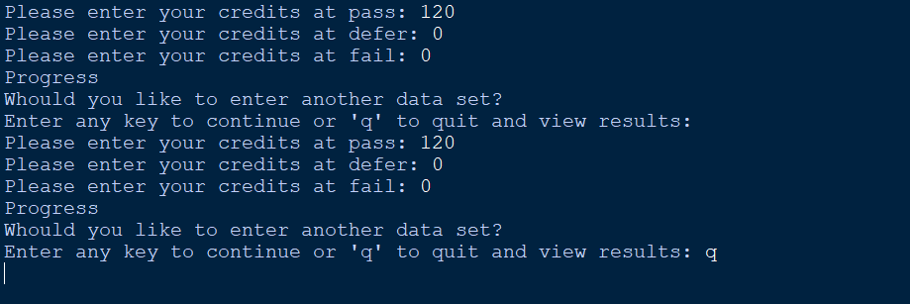

**7.1) and 7.2)**

